OUR PROJECT -

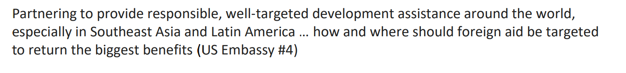

* Rao, D. T., Sethi, N., Dash, D. P., & Bhujabal, P. (2023). Foreign aid, FDI and economic growth in South-East Asia and South Asia. *Global Business Review*, *24*(1), 31-47.

Aid broadly aims at stimulating economic growth by financing health and educational infrastructure, strengthening of political institutions, providing emergency relief, and stabilizing economies that are afflicted by supply shocks.

-> 1. finance health infrastructure (O)

2. finance educational infrasturcture

3. strengthen political institutions (O)

4. provide emergency relief (O)

5. stabilize economy from supply shocks

* what is the problem of South Asia?
* <https://www.kaggle.com/datasets/vinayshanbhag/us-foreign-aid>
* kaggle
* foreign aid be targeted to return the biggest benefits
  + some benefits ?
  + target -> ?

\*\***selection of the best country for foreign aid from data analysis**\*\*

1. what is foreign aid?
2. what is the benefit of foreign aid?
3. what is the **purpose** of foreign aid?

Suggestions for our topic

1. correlation(return *benefits* & estimated *input*)
   1. benefits and input should be obtained from lit review and data gathering
   2. also, we can use Machine Learning for prediction of benefits from input.
   3. -> result : model that return benefits from given input & country
2. Recommendation system for aid-needed country
3. Clustering aid-needed country and give appropriate aid method